Hackathon Assignment 6

General Directions: Please answer each question in a Word document as follows: 1) Copy your SQL query and 2) Attach a screen shot of the output. Please submit both the Word document and SQL script for grading. Each question is worth 10 points.

1. Get a list of orderNumber where the order amount was more than $50,000. Hint: Use a subquery as a column

select

orderNumber,

(select

sum(od.quantityOrdered\*od.priceEach)

from orderdetails od

where od.orderNumber = o.orderNumber) as 'Amount'

from orders o

having amount > 50000

order by amount desc;

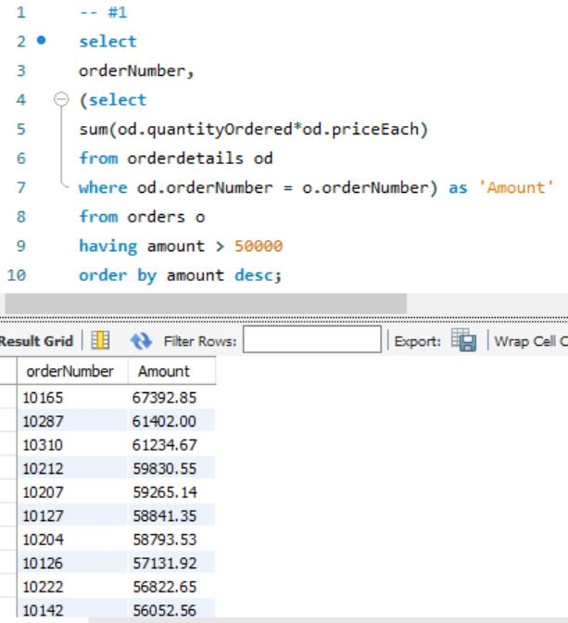

1. Get a list of customerName and orderNumber for orders of more than $50,000. Hint: Use a join with the query from #1.

select

c.customerName,

orderNumber,

(select

sum(od.quantityOrdered\*od.priceEach)

from orderdetails od

where od.orderNumber = o.orderNumber) as 'Amount'

from orders o

left join customers c

on o.customerNumber = c.customerNumber

having amount > 50000

order by amount desc;

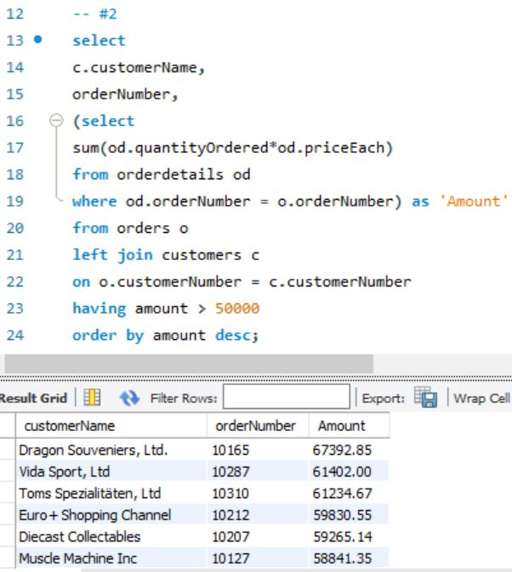

1. Which customers have not placed an order? Hint: Use a subquery to find customerName who are in both orders and customers table. Next, use a primary query with the WHERE NOT EXISTS keywords to find customerName who are in the customers table but not the subquery.

select

c.customerName

from customers c

where not exists

(select

o.customerNumber

from orders o

where c.customerNumber = o.customerNumber);

